Nilkanthrao Shinde Science and Arts College, Bhadrawati Dist. Chandrapur.
Alumni Association
Report of Blood Donation Camp
Blood donation camp organizes by college in association with State Blood Transfusion Council, General Hospital, Chandrapur and Alumni Association on 26th February 2021 in Hall of Indoor Stadium with respect to all rules and regulation of Covid-19 pandemic disease.
The Chief Guest:
• Dr. Vivek N. Shinde – Joint Secretary Bhadrawati Shikshan Sanstha, Bhadrawati.
• Dr. Kartik N. Shinde – Member, Bhadrawati Shikshan Sanstha, Bhadrawati.
• Dr. Vishal N. Shinde – Member, Bhadrawati Shikshan Sanstha, Bhadrawati.
• Shri Sanjay Gawit, General Hospital, Chandrapur
• Shri Yogesh Jarunde, General Hospital, Chandrapur
• Shri Nitin Asutkar, Member, Alumni Association
• Shri Praveen Kamble, Member, Alumni Association
• Shri Ajij Sheikh, Member, Alumni Association

Chairman of the Blood Donation Camp:
• Dr. L. S. Ladke, Principal, Nilkanthrao Shinde Science and Arts College,
Bhadrawati.

General Information:
• Total 48 persons were donated blood during blood donation camp including student, teaching and nonteaching staff, principal, members of BSSB and alumni.

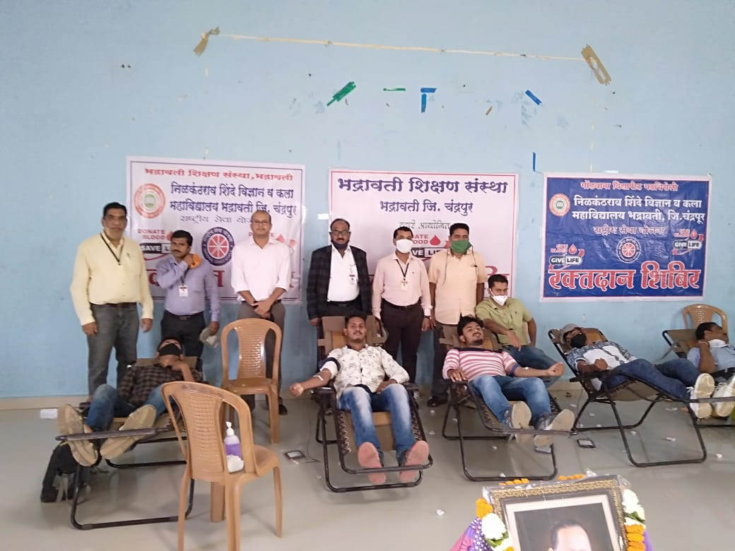
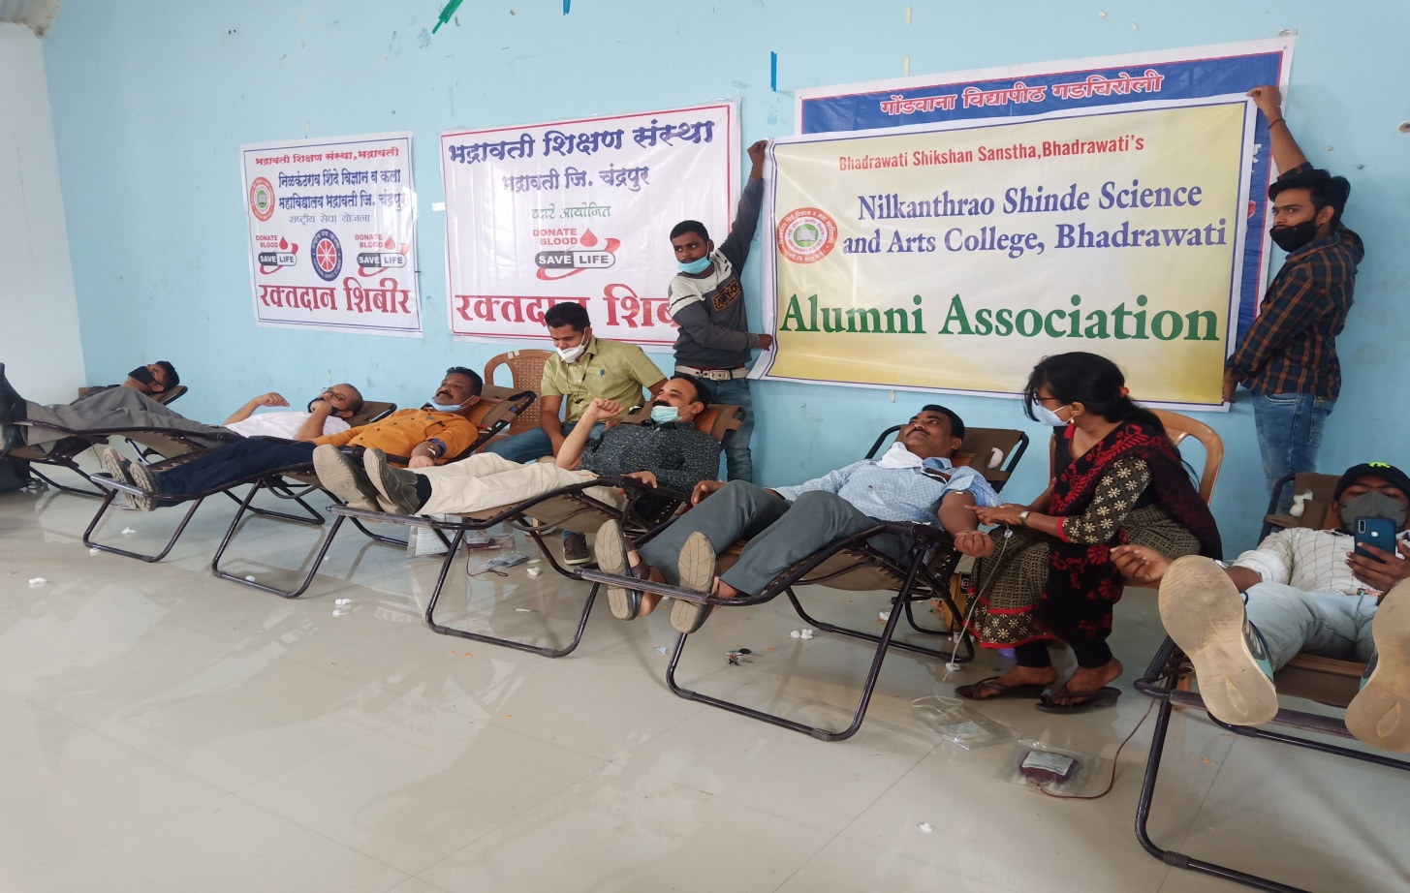
Blood donated by Alumni

