Nilkanthrao Shinde Science and Arts College, Bhadrawati Dist. Chandrapur.
Alumni Association
Report
The meeting of alumni association was held on 3-11-2019 in Auditorium Hall of college.
Chairman :
• Dr. L. S. Ladke, Principal, Nilkanthrao Shinde Science and Arts College, Bhadrawati.

Chief Guest:
• Shri Jagannath Nanaware
• Shri Amit Chaudhari
• Shri Praveen Kamble
• Miss Nagkanya Vijay
• Shri Praveen Kamble
• Shri Ajij Sheikh

Organizer :
• Dr. Narendra V. Harney

General Information:
• The meeting of Alumni association was held on 3-11-2019 in Auditorium Hall of college.
• The meeting is chaired by Dr. L.S. Ladke, Principal, Nilkanthrao Shinde Science and Arts College, Bhadrawati
• The guest of meeting is our alumni such as Shri Jagannath Nanaware, Shri Amit Chaudhari, Shri Praveen Kamble, Miss Nagkanya Vijay, Shri Praveen Kamble and Shri Ajij Sheikh.
• The function is start with the introduction of Chairman and Guest by Dr. Narendra V. Harney, organizer of this function.
• After that some alumni share their experience about college and suggest some ideas for betterment of college.
• During this meeting some new alumni were registered .
• The function is over by delivering the presidential speech by Principal, Dr. L.S. Ladke.
• Vote of thanks given by Dr. G.R. Bedare

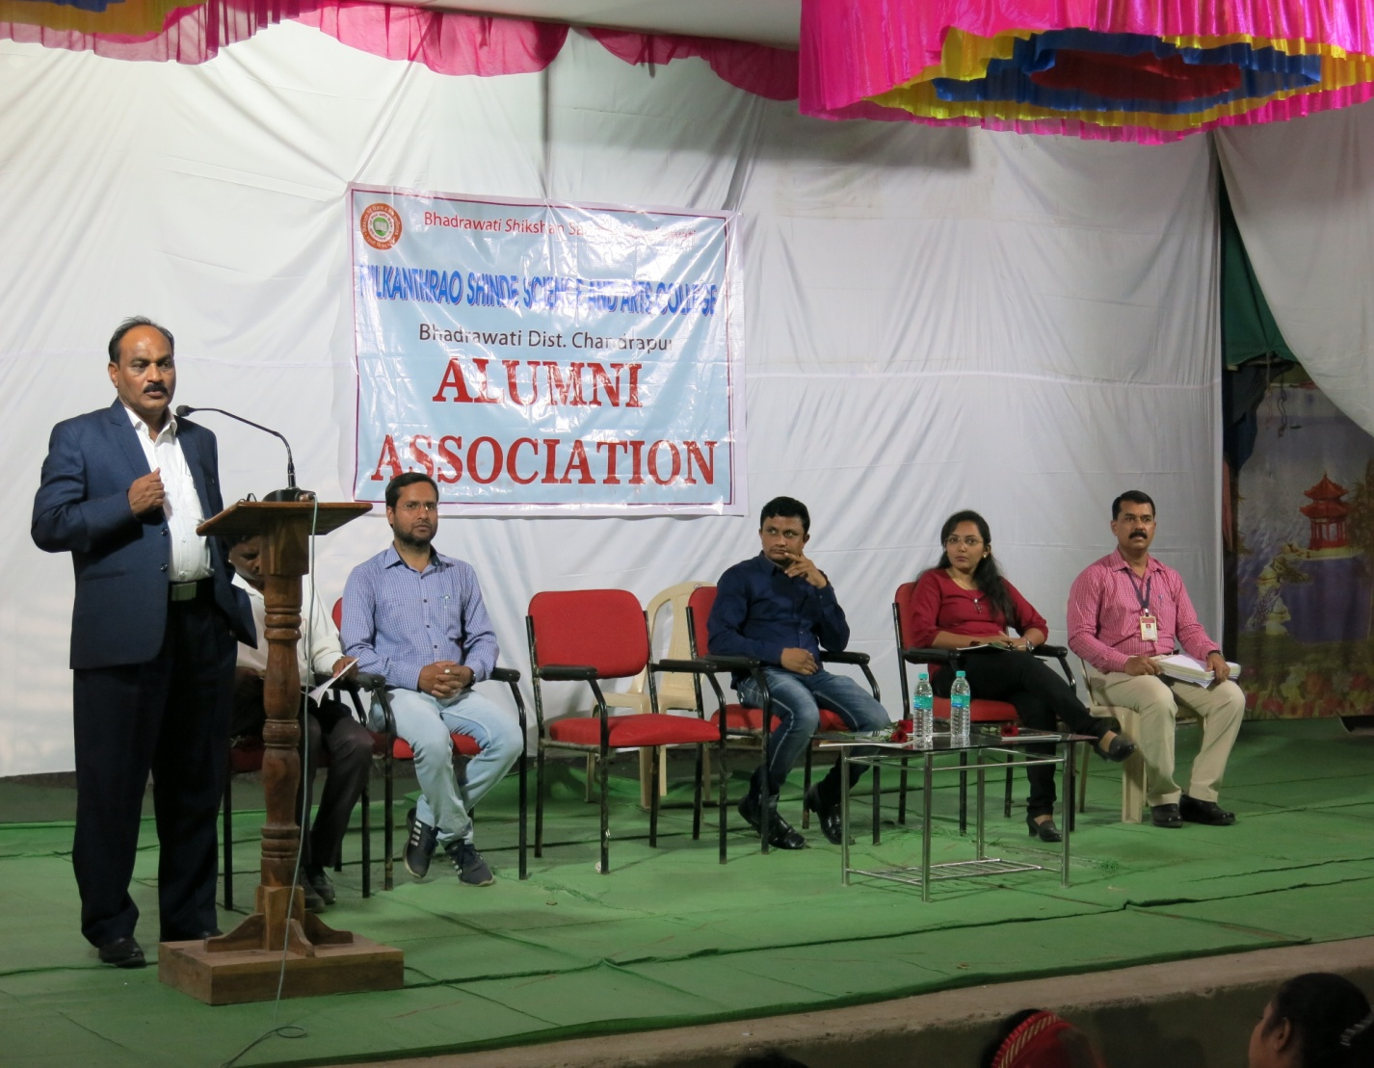
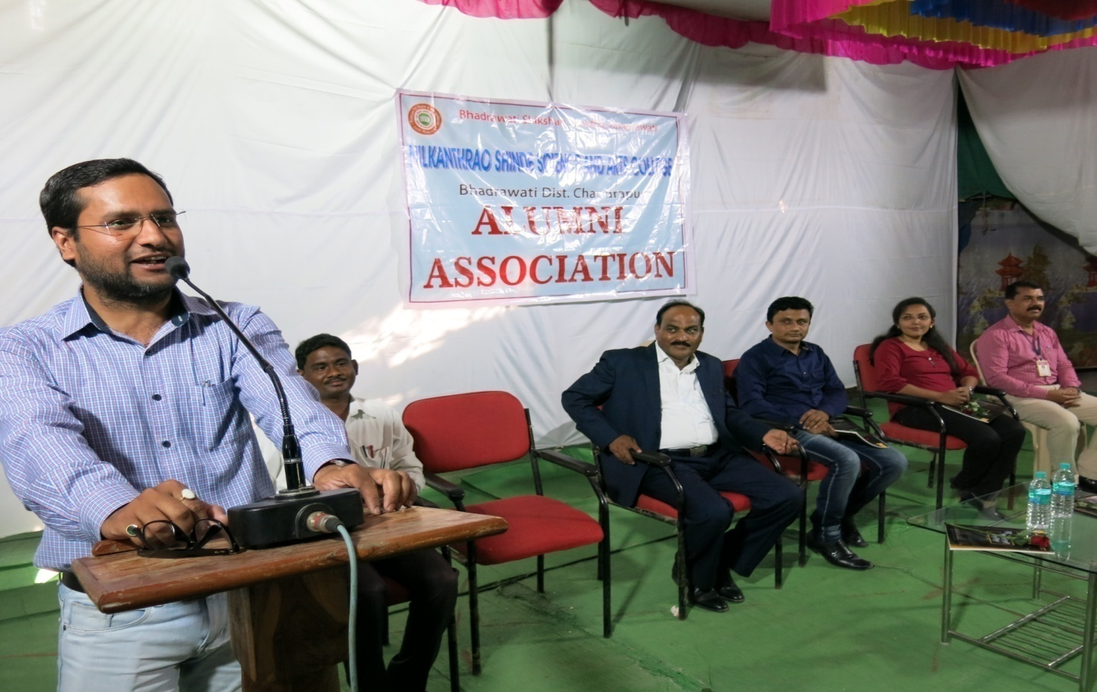
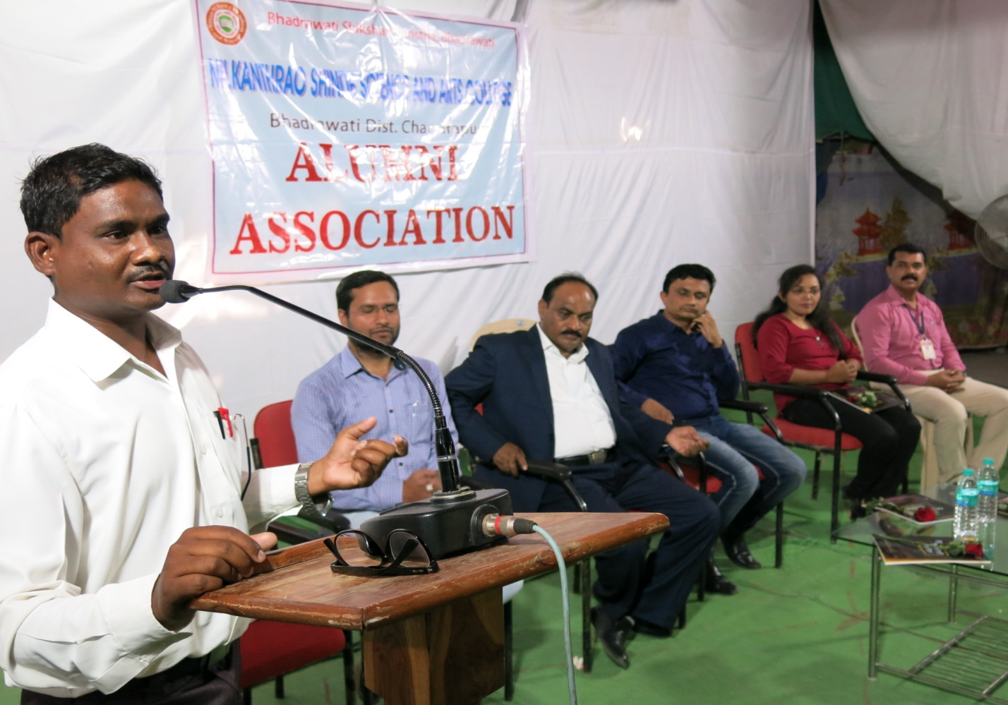
Meeting of Alumni Association

